 | Pimpri Chinchwad Education Trust’s  Pimpri Chinchwad College of Engineering  (PCCoE)  (An Autonomous Institute)  Affiliated to Savitribai Phule Pune University(SPPU) ISO 21001:2018 Certified by TUV | 
Course: DevOps Laboratory | Code: BIT26VS01
Name: Amar Vaijinath Chavan | PRN: 124B2F001
Assignment 9: Exploration of Docker Architecture and Containerization of a Python Application.

Aim: To explore Docker architecture and core commands by containerizing a Python Flask
using a Dockerfile.

Objectives:
- To understand the Docker Client-Server architecture.
- To learn the syntax and instructions of a Dockerfile.
- To build, run, and manage Docker containers using the CLI.

Theory

Docker Architecture

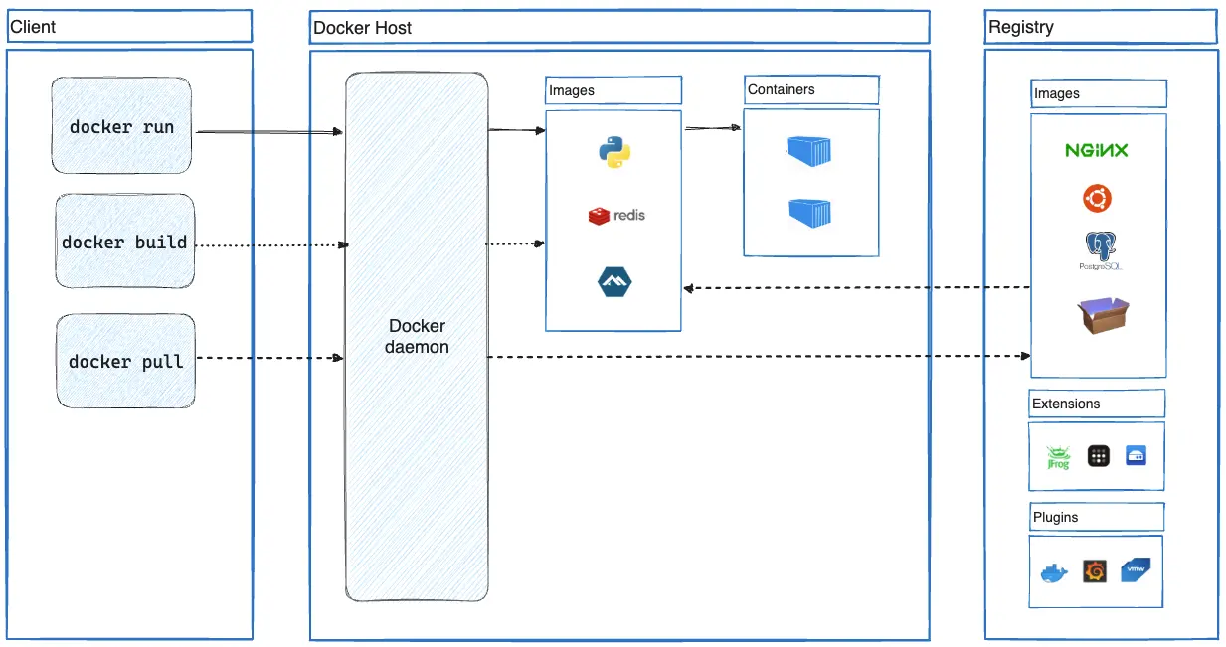

Docker uses a client-server architecture. The Docker Client talks to the Docker Daemon (dockerd), which does the heavy lifting of building, running, and distributing your Docker containers.
- The Docker Daemon: A persistent background process that manages Docker objects such as images, containers, networks, and volumes.
- The Docker Client: The primary way that many Docker users interact with Docker. When you use commands such as docker run, the client sends these commands to dockerd, which carries them out.
- Docker Registries: A registry stores Docker images. Docker Hub is a public registry that anyone can use.
- Docker Objects:
- Images: A read-only template with instructions for creating a Docker container.
- Containers: A runnable instance of an image. You can create, start, stop, move, or delete a container using the Docker API or CLI.

Dockerfile Instructions

A Dockerfile is a text document that contains all the commands a user could call on the command line to assemble an image.

- FROM: Sets the Base Image for subsequent instructions.
- WORKDIR: Sets the working directory for any subsequent instructions.
- COPY: Copies new files or directories from the source and adds them to the filesystem of the container.
- RUN: Executes any commands in a new layer on top of the current image and commits the results.
- EXPOSE: Informs Docker that the container listens on the specified network ports at runtime.
- CMD: Provides defaults for an executing container. There can only be one CMD instruction in a Dockerfile.

Practical Procedure / Steps

Step 1: Application Structure

The application is a Student Management System built using the Flask framework. The project structure consists of the following files:
- app.py: The backend Flask logic for CRUD operations.
- requirements.txt: Lists the flask dependency.
- templates/index.html: The frontend UI.
- static/style.css: Custom CSS for the UI.

Step 2: Defining the Dockerfile

A Dockerfile was created in the root directory with the following configuration:

FROM python:3.12-slim
WORKDIR /app
COPY requirements.txt .
RUN pip install --no-cache-dir -r requirements.txt
COPY . .
EXPOSE 5000
CMD ["python", "app.py"]

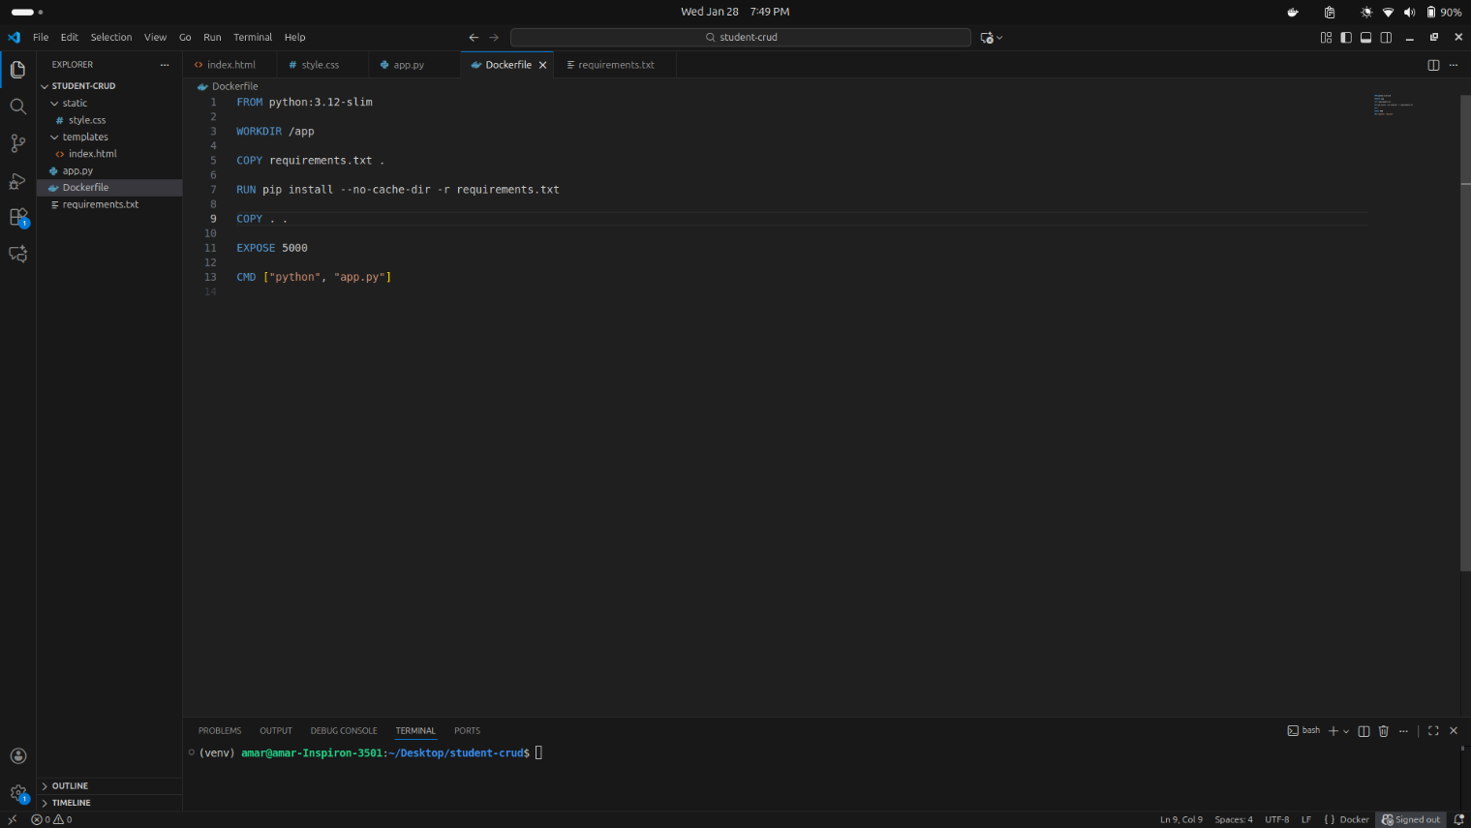

Step 3: Building the Docker Image

Using the terminal, the image was built and tagged as student-crud-app.
docker build -t student-crud-app .
The build process involves 10 steps, each creating a layer in the final image.

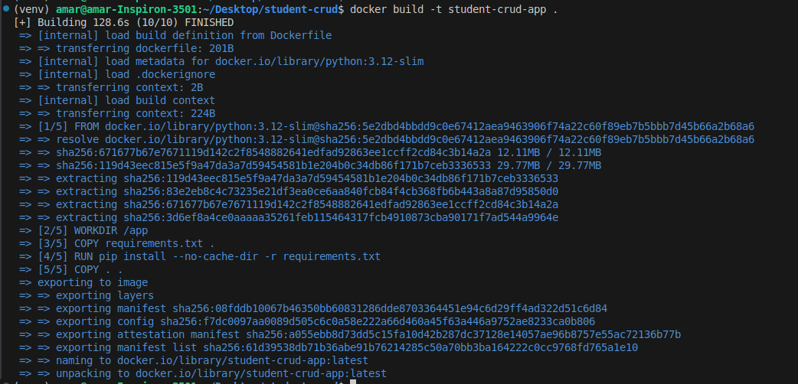
Step 4: Running the Container
The container was started by mapping the host port 3000 to the container port 5000.

docker run -p 3000:5000 student-crud-app

Verification was performed by accessing http://localhost:3000 in the browser, showing the functional Student Management System.

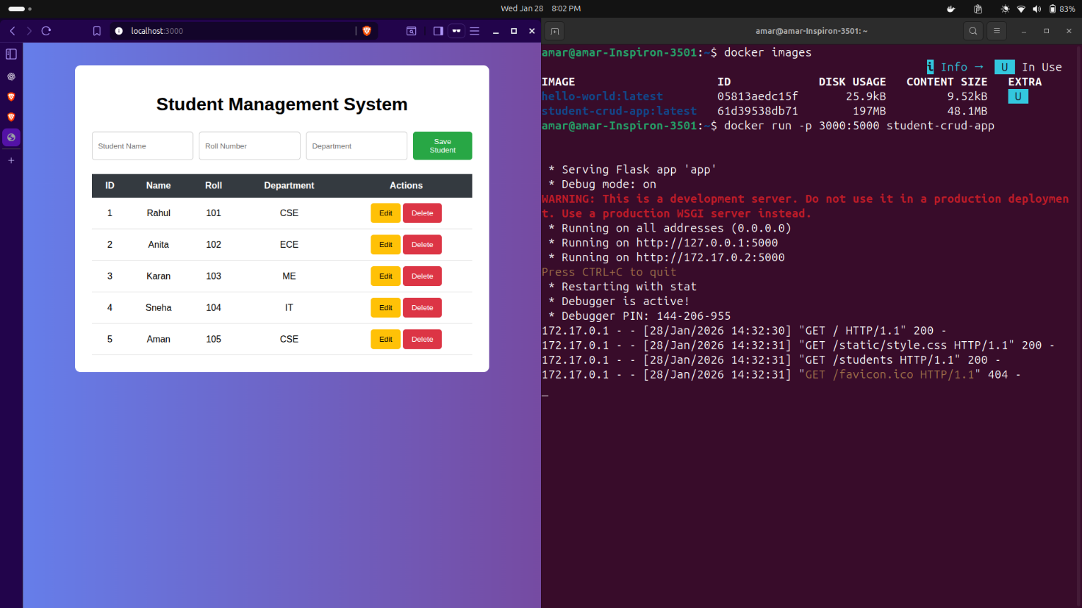
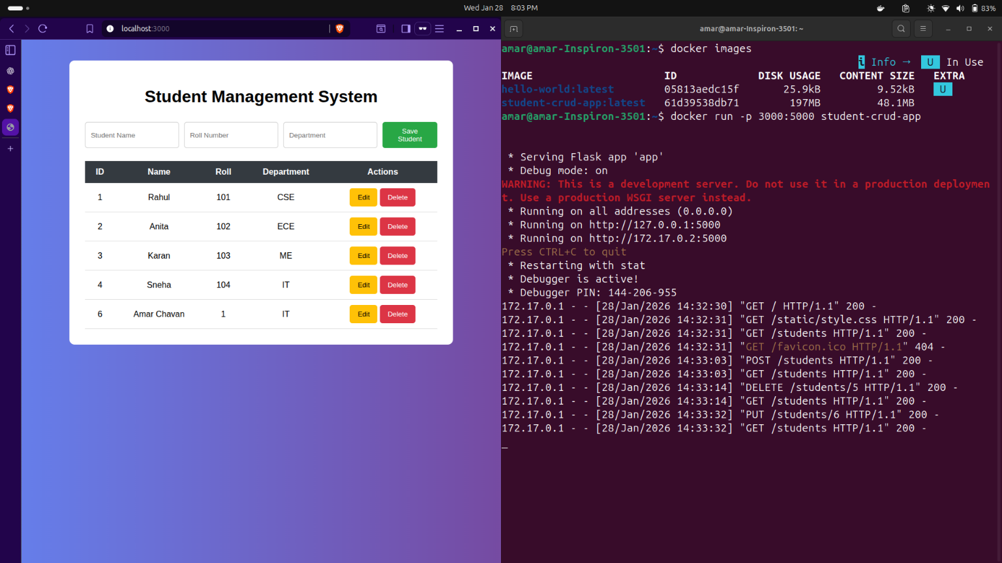

Step 5: Managing Images and Containers

The following commands were used to verify the state of the Docker environment:
- docker images: Confirmed the creation of student-crud-app:latest with a size of approximately 197MB.
- docker ps -a: Showed the status of the container, including its ID and uptime.
- sudo systemctl status docker: Verified that the Docker daemon was active and running.

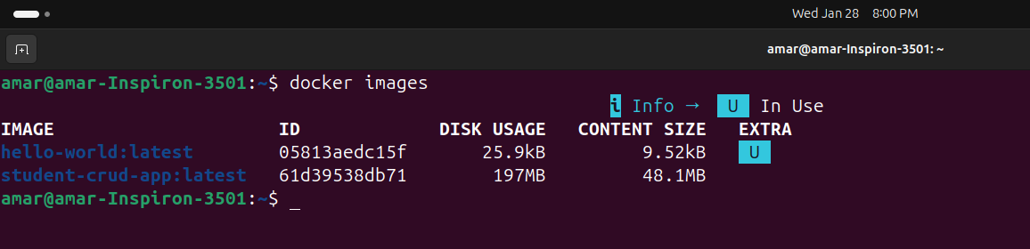
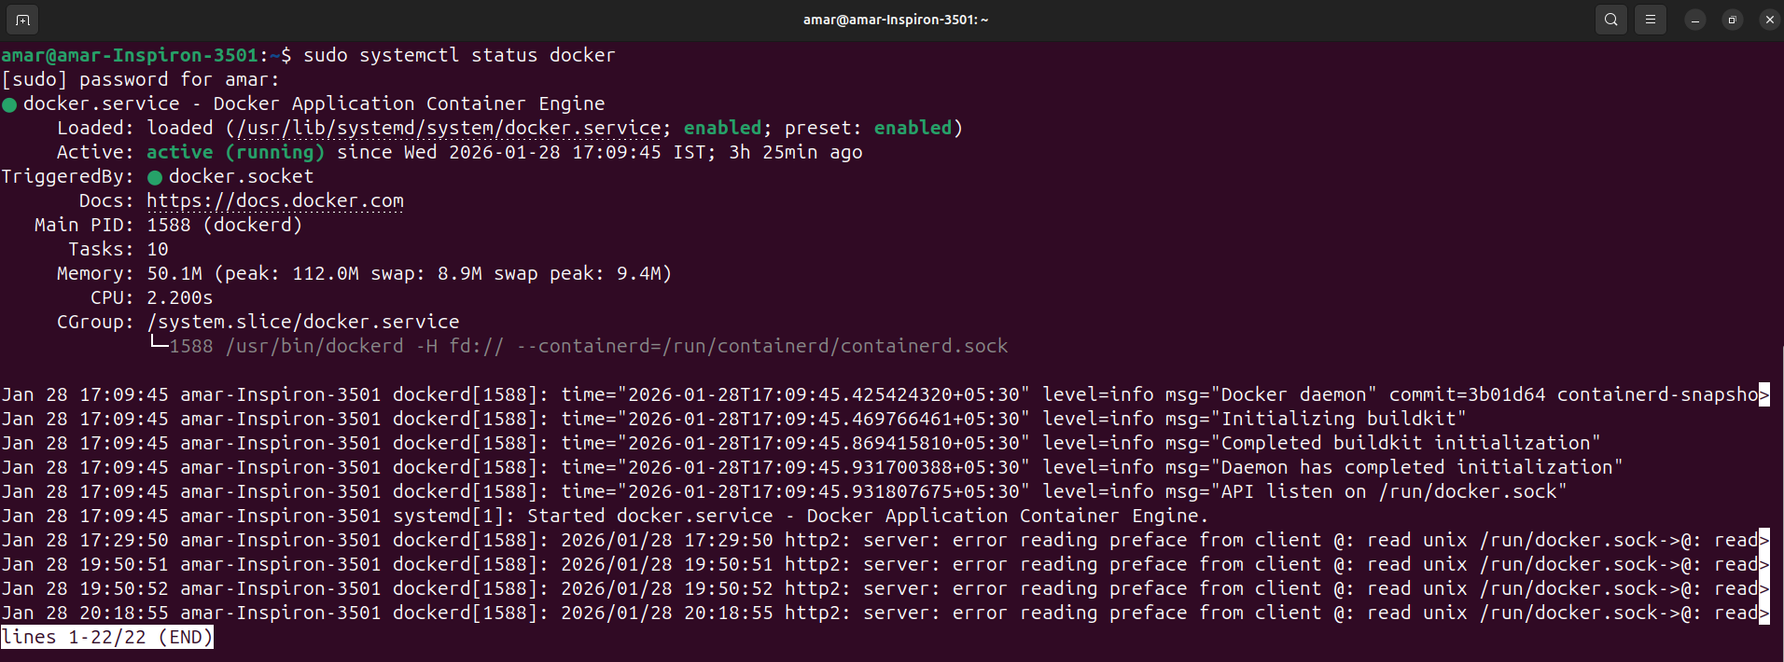
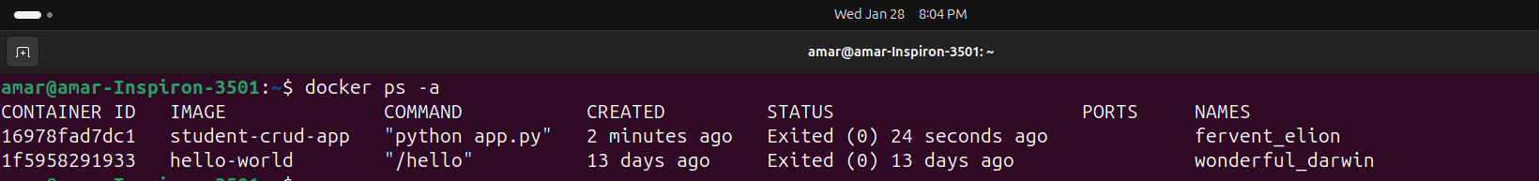
Conclusion
The successful completion of Assignment 9 provides a comprehensive understanding of Docker’s client-server architecture and the practical application of containerization. By developing a Dockerfile for the Student Management System, it was demonstrated how an application, along with its specific dependencies like Flask, can be packaged into a portable and immutable image. The build process highlighted the importance of Layer Caching, which optimizes efficiency by only rebuilding modified parts of the application. Furthermore, the successful verification on localhost:3000 confirmed that Docker ensures environment consistency, allowing the application to run seamlessly across different systems.

